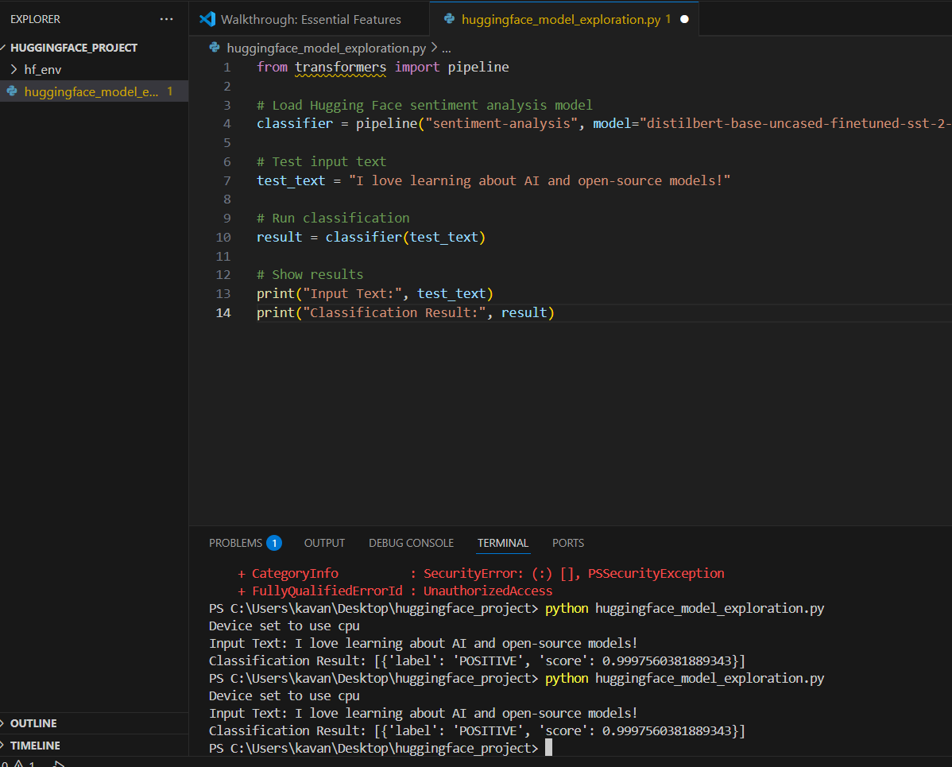
Result:

Program:
from transformers import pipeline
# Load Hugging Face sentiment analysis model
classifier = pipeline("sentiment-analysis", model="distilbert-base-uncased-finetuned-sst-2-english")
# Test input text
test_text = "I love learning about AI and open-source models!"
# Run classification
result = classifier(test_text)
# Show results
print("Input Text:", test_text)
print("Classification Result:", result)

Environment setup commands:
Transformers ,torch

